**Data Structures and Algorithms**

**Lab report: 3**

|  |  |
| --- | --- |
| **Name:** | **Ali Salman** |
| **Reg no:** | **FA22-BCE-005** |
| **Class:** | **BCE-3A** |
| **Lab Instructor:** | **Dr. Ali Mustafa** |

**Lab 03**

**Advanced Topics in Singly Linked List Implementation**

**In-Lab Task 1:**

1. **i*nsert at the beginning***:

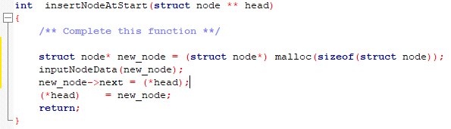

1. ***insert before***:

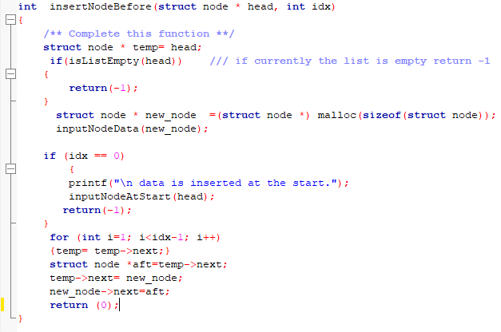

**In-Lab Task 2:**

1. ***delete from beginning***:

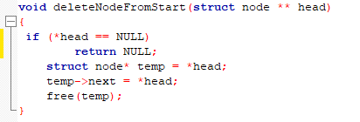

1. ***delete after***:

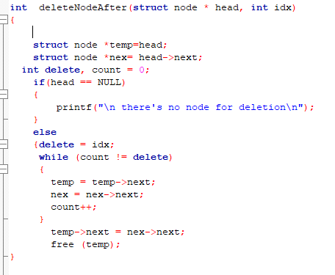

**Post-Lab Task:**

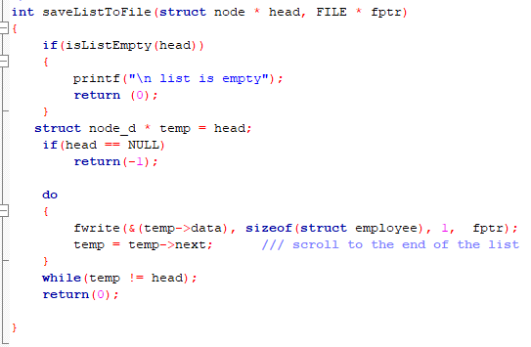

**Critical Analysis:**

In this lab, we learned the implementation of insertion and deletion of nodes. It’s quite difficult to maintain extra nodes in it and in assigning values to them. We learned that the file should be closed after saving list to file.

To insert a node at beginning, a new node is allocated and also assigned the address of head pointer. We must update the head pointer in order not to lose the start of linked list. To add a node before a specified index, we have to maintain 3 pointers. 1st indicated the index specified node,2 nd indicates the previous node and 3rd indicates the node to be added. We have to assign the address of new node to previous node and give new node the address of index specified node.

To delete node from beginning, we just have to update the head node to next node and deallocate the memory of 1st node. To delete a node after a specified index, we have to maintain 2 pointers. 1st indicates the index specified node and 2nd indicates the node to be deleted. We assign the next of to be deleted node to the next of index specified node and deallocate the memory for desired node

In post lab,to save a list to file, we must check whether the list is empty. If not, then write the entered data in the file “employee.h” by using fwrite function. We use do while loop instead of while because we want to write the data of last node which cannot be written using while loop because the condition is checked before implementation.